e
INSTITUTO SUPERIOR POLITÉCNICO DE TECNOLOGIAS E CIÊNCIAS

GEOSCIENCES DEPARTMENT
TPA COURSE IN PETROLEUM ENG. AND GEOCIENCES

TECHNICAL REPORT

BASIN EVALUATION AND EXPLORATION IN PETROLEUM
GEOSCIENCES

RESERVOIRS AND RESOURCES IN BLOCK 15/06
LOWER CONGO BASIN (ANGOLA)

Title: What are the RESERVOIRS and the RESOURCES of the ANGOLA block 15/6 ?

TEAM 17
Rocélio Da Silva | Petroleum Eng. ? 20220001
Benvindo Chilela | Geophysicist ? 20222020
Maria Sonça | Geophysicist ? 20230900

Supervisor: Pr. Dr. Jacques Durand, HDR
TOTAL ENERGIES PROFESSORES ASSOCIADOS

Luanda 15 September 2025

Abstract

Block 15/06 is a premier deepwater concession of the Lower Congo Basin, about 350 km NW of Luanda and 130 km off Soyo, covering ~2,980 km2 in water depths of 400-1,500 m^{[2][3][1][4][12]}
Key words: Reservoirs; Resources; Block 15/06; Lower Congo Basin; Turbidites; FPSO.

List of Figures

Figure 1 - Geographic delimitation of Block 15/06.
Location map of the Lower Congo Basin showing Block 15/06 (2,980 km2) about 350 km NW of Luanda and 130 km offshore Soyo, in the 400-1,500 m water-depth range [2].
Figure 2 - Regional tectono-stratigraphic column of the Lower Congo Basin.
Composite column from Pre-Cambrian basement to Quaternary showing Pre-Rift, Syn-Rift (Bucomazi source rock + Loeme salt) and Post-Rift megasequences, and the Oligo-Miocene turbidite reservoirs [8, 10].
Figure 3 - Interpreted regional 2D seismic line.
Regional 2D section showing top-basement, syn-rift half-grabens, Aptian salt and the post-salt wedge - the structural framework controlling the traps of Block 15/06 [8].
Figure 4 - The oil and gas workflow

List of Tables
Table 1 (in body): Reserves 1P / 2P / 3P of Block 15/06 - answer table [1, 11].
Tables A1-A8 (in Annex): consortium, phases, tectono-stratigraphy, field discoveries, petroleum system, technology enablers, key wells, FPSO hubs.

List of Annexes
A1- Consortium and regulation
A2- Historical phases
A3 -Tectono-stratigraphy
A4 -Field discoveries
A5 -Petroleum system
A6- Technology
A7 -Key wells
A8 -FPSO hubs.

Introduction

This report answers, in a clear and structured way, the title question: what are the reservoirs and the resources of the Angola Block 15/06 ? The block is a premier deepwater concession of the Lower Congo Basin, ~350 km NW of Luanda and 130 km off Soyo, covering ~2,980 km2 in 400-1,500 m water depth^{[2][4]}

CHAPTER 1 - STATE OF KNOWLEDGE AND METHODOLOGY

1.1 Data base file creation (Methodology)
Per the TPA Course 2026 requirements, a single, continuously-updated database was built in the folder TPA Course / Reports. Report text, figures, tables and notes were saved every half day (morning and afternoon) and every evening to avoid data loss and preserve version history. Workflow: collect public ANPG / Azule Energy / Eni bulletins; store figures and tables in dedicated sub-folders; log every discovery, well, FPSO and field in a master spreadsheet; harmonise units (m, km2, bbl, boe, MMbbl, Bbbl) and API gravity; cross-check numbers against ANPG and operator data before building each chapter^{[1][2][4]}

1.2 State of Knowledge

1.2.1 Block localisation and story (Azule Energy and before, operatorship, associates)
Block 15/06 is in deep offshore in the Lower Congo Basin, ~350 km NW of Luanda and 130 km off Soyo, ~2,980 km2, 400-1,500 m water depth. Figure 1 shows its geographic delimitation, illustrating the nomenclature (Block 15 = macro-geographic licence area; 06 = sub-block awarded in the 2006 round)^{[2][4][4][4][7]}

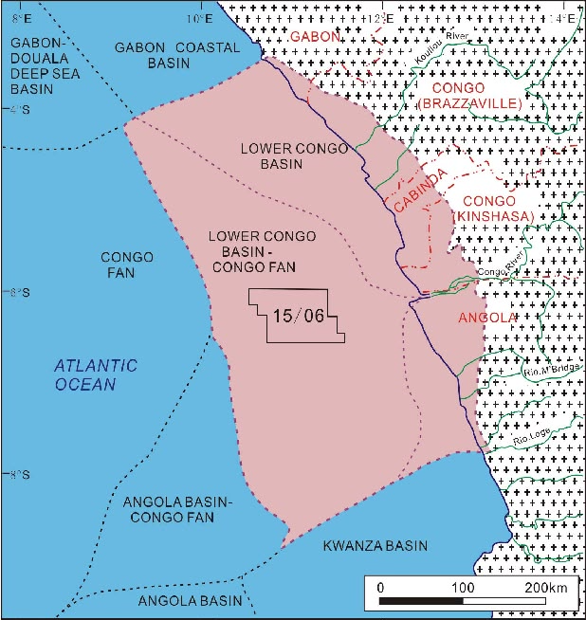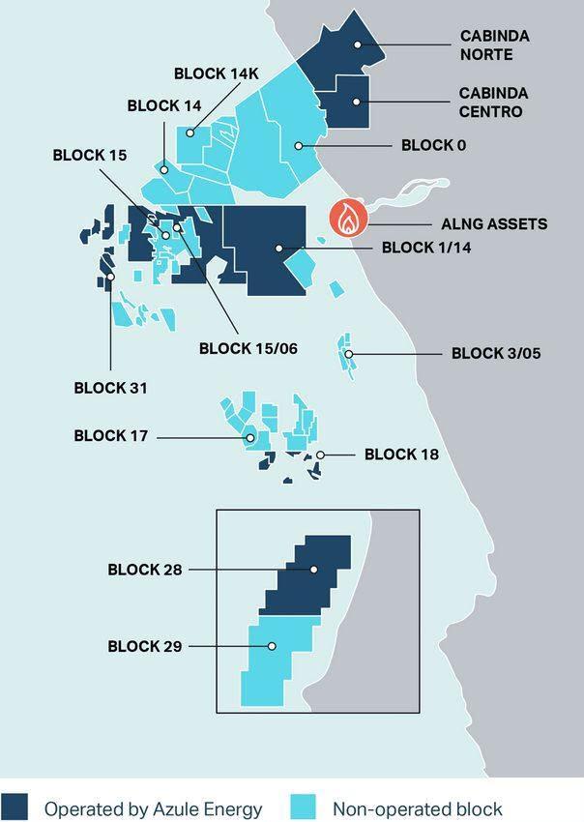
Figure 1 - Geographic delimitation of Block 15/06.
Location map of the Lower Congo Basin showing Block 15/06 (2,980 km2) about 350 km NW of Luanda and 130 km offshore Soyo, in the 400-1,500 m water-depth range

1.2.2 Geological context (Basin, stratigraphy, regional section)

The Lower Congo Basin is a passive-margin basin formed during South Atlantic rifting in the Early Cretaceous. Figure 3 shows the regional tectono-stratigraphic column and its four stages: Pre-Rift (Neocomian, basement fracturing and tholeiitic volcanism); Syn-Rift (Valanginian-Aptian, half-grabens with Bucomazi Fm lacustrine shales - main source rock - and Loeme Fm salt - main seal); Post-Rift (Albian-Santonian, thermal subsidence, marine carbonate/clastic deposition); and Regional Subsidence & Gravity Tectonics (Eocene-Present, halokinesis of Aptian salt and deepwater Oligo-Miocene turbidites - the main reservoirs)^{[8][10]8]}

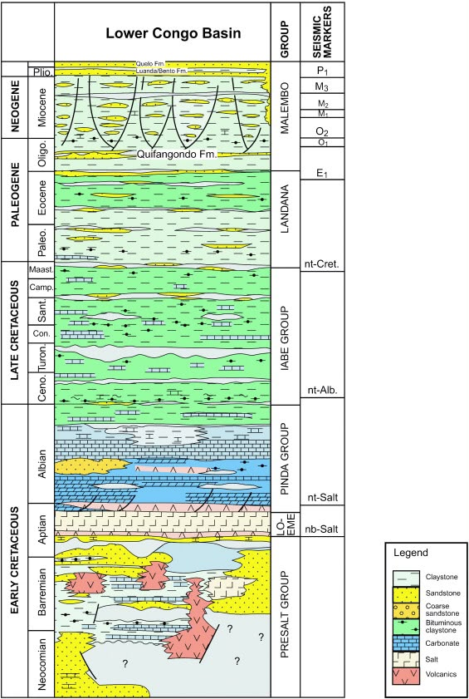
Figure 2 - Regional tectono-stratigraphic column of the Lower Congo Basin.
Composite column from Pre-Cambrian basement to Quaternary showing Pre-Rift, Syn-Rift (Bucomazi source rock + Loeme salt) and Post-Rift megasequences, and the Oligo-Miocene turbidite reservoirs

1.2.3 Geophysics (2D seismic campaigns, regional seismic section)

Knowledge of Block 15/06 relies on regional 2D surveys (Figure 4), broadband multi-component 3D seismic for Miocene channel imaging , Ocean Bottom Node (OBN) acquisition for sub-salt imaging (full-azimuth, long-offset), and Full Waveform Inversion (FWI) for salt-velocity modelling and accurate positioning of steep salt flanks^{[3][6]}salt structures, channels, salt diapir flanks and turtle-back anticlines, and provided the geometry for well planning and geosteering (Annex A6)^{[3]}

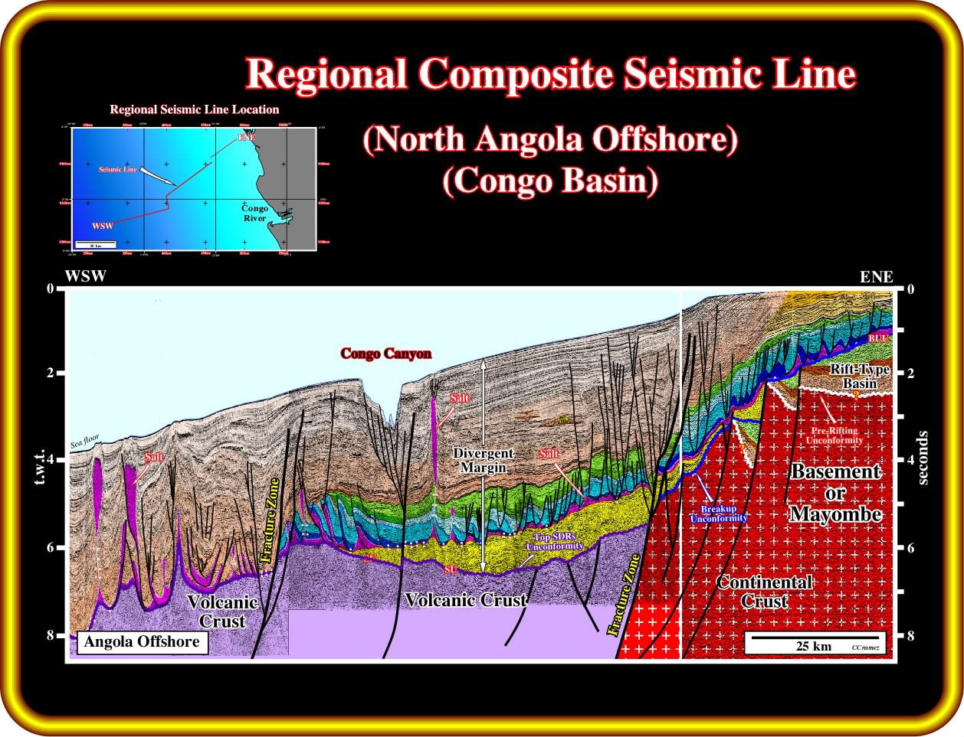
Figure 3 - Interpreted regional 2D seismic line.
Regional 2D section showing top-basement, syn-rift half-grabens, Aptian salt and the post-salt wedge - the structural framework controlling the traps of Block 15/06 [8].

1.2.4 Basin Geometry and story
The basin geometry results from the interplay of rifting, thermal subsidence and salt tectonics. Halokinesis of Aptian salt generated turtle-back anticlines, salt diapir flanks, sub-salt closures and tilted fault blocks - the main structural traps of Block 15/06^{[11][3][11]}

CHAPTER 2 - RESERVOIRS OF THE BLOCK 15/06

2.1 Exploration and Appraisal Situation - Field Discoveries
Block 15/06 holds 22 commercial discoveries across three hubs (West Hub, East Hub, Agogo Integrated West Hub) with exploration success >80%, driven by broadband 3D, OBN and FWI^{[3][4][4][6][7]}

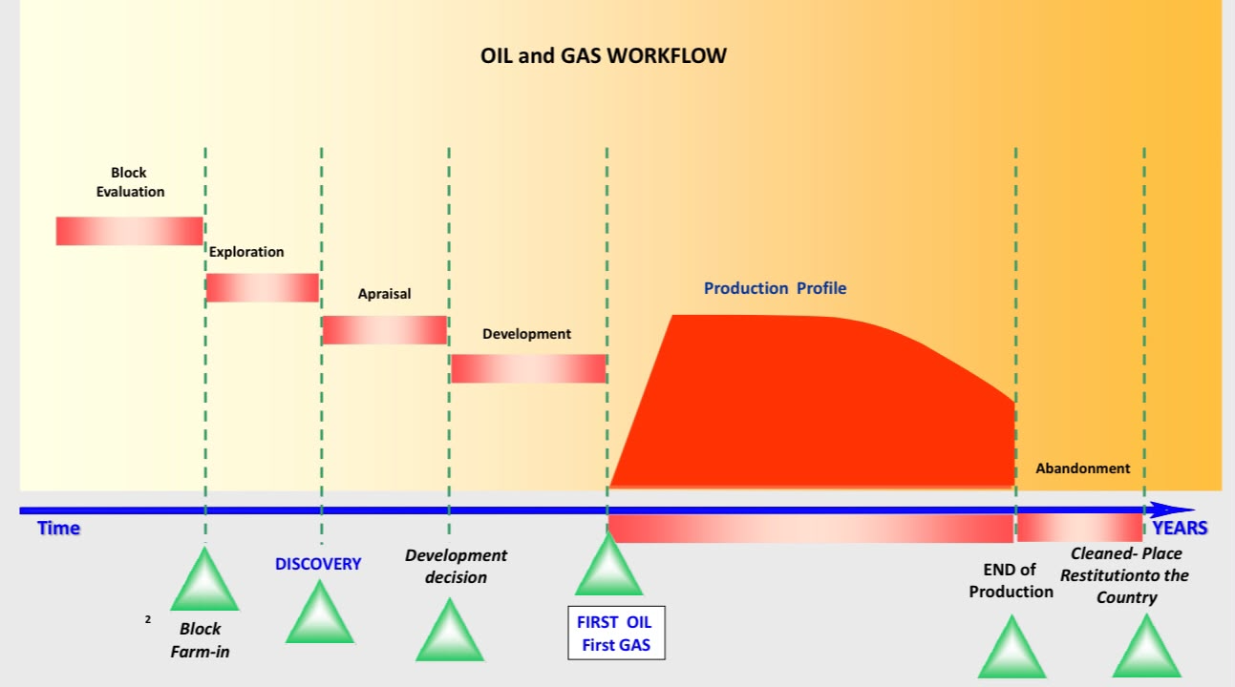
Figure 4 - The oil and gas workflow

2.2 Depositional environments and basin geometry
The primary reservoirs were deposited by gravity-driven deepwater processes ; channel-levee and overbank deposits (thinner, finer sand-shale alternations of rapidly decreasing quality away from the axis); and basin-floor lobes (broad sheets several km2 in extent, tens of metres thick, laterally continuous - the easiest targets for vertical or high-angle wells)^{[3]}

2.3 Geometries and architecture (seismic and geology)
Salt movement strongly reworked the original turbidite geometries. shows sinuous channel fairways and their pinch-out margins;^{[3][6][11][3]}

2.4 Gross and net reservoir volumes
The gross reservoir package is the Oligo-Miocene turbidite interval, which can reach 500-1,500 m of drilled pay in horizontal wells. NTG is very high in channel-core facies (80-95%) and drops rapidly in levee/overbank facies. Main intervals: Lower Oligocene (Nduungu type), Lower-to-Middle Miocene (Agogo, Cuica, Cabaca, Sangos, Cinguvu, Mpungi, Vandumbu, Ochigufu types), and Upper Miocene (Algaita type)^{[5]}

2.5 Petrophysical features
Lithology: unconsolidated to poorly consolidated, clean, fine-to-coarse-grained quartzose turbidite sandstones. Effective porosity 23-30%. Permeability 1-3 Darcies. Individual well flow rates are often above 15,000 bopd. NTG 80-95% in channel cores; lower in levee/overbank. Fluid quality: medium-to-light sweet crude, low sulfur (<0.3-0.5%)^{[5]}

2.6 Type of fluids recovered, Net oil
Block 15/06 produces medium-to-light sweet crude oils. API gravity ranges from 24 deg to 38 deg depending on the field (Agogo ~31, Nduungu ~35, Cuica ~38, Cabaca ~34, Cinguvu ~23)^{[4][6][1][11]}

CHAPTER 3 - RESERVES AND RESOURCES OF THE BLOCK 15/06

3.1 Pre-development, developments fields in process
On stream: West Hub (FPSO N'Goma) and East Hub (FPSO Olombendo). Under development: Agogo Integrated West Hub (FID Feb 2023, US$ 7.8 B) hosting Agogo, Nduungu and Cuica^{[4][7]}

3.2 First oil and Production wells
First oil dates: West Hub (FPSO N'Goma) - Dec 2014; East Hub (FPSO Olombendo) - Feb 2017; Agogo Integrated West Hub (FPSO Agogo) - 2025^{[4][12][5][5]}

3.2.1 kind of oil

Block 15/06 offshore Angola contains light, high-quality conventional crude oil.
Type: Light, high-quality crude oil.
API Gravity: Measured at high quality, such as around 37° API in fields like Afoxé.

3.3 Infrastructures (Pipelines, FPSO, ...)
Block 15/06 uses a hub-and-tie-back architecture (Figure 8): all fields are subsea, flowing via manifolds, flowlines, risers and umbilicals to three central FPSOs. FPSO N'Goma (West Hub, ~100,000 bbl/d) serves Sangos, Cinguvu, Mpungi, Vandumbu and Ochigufu. FPSO Olombendo (East Hub, ~80,000-100,000 bbl/d) serves Cabaca Norte, Cabaca Sudeste, UM8 and Cabaca High. FPSO Agogo (Agogo Integrated West Hub, ~120,000 bbl/d) serves Agogo, Nduungu and Cuica^{[4][12][4][5]}

3.3.1 Recent Discoveries
The Exploration activities in the block 15/06 goes very well and expands the block's lifecycle, highlighted by a major 2026 discovery at the Algaita-01 well estimated at around 500 million barrels of high-quality oil.

3.4 Oil and Gas production of the Block 15/06 (Reserves 1P, 2P, 3P)
Total STOIIP across the block is 3.0-4.0 Bbbl with 1.5-2.0 Bboe of ultimate technically recoverable resources over 22 discoveries^{[1][11][4][12][5][7]}
3.4.1 Key Details on Block 15/06
Plateaus
A production plateau in
Peak Output Targets: Facilities like the N'goma FPSO (West Hub) and Armada Olombendo FPSO (East Hub) are designed around specific processing capacities—such as 100,000 barrels of oil per day (bopd) per vessel—to hold a steady production rate.
Sustaining the Plateau: Because natural reservoir production declines over time, operators (managed via Azule Energy / formerly Eni) tie in new discoveries and satellite fields—like Vandumbu, Cuica, Cabaça Norte, and Ndungu—to extend and maintain this peak plateau level for as long as possible
3.4.2 refineries in angola
Angola has two operational oil refineries and several major new refining projects under development to reduce its reliance on fuel imports.
Luanda Refinery: Operated by Sonangol and located in Luanda Province, it is a historical facility processing around 65,000 to 72,000 barrels per day (bbl/d) following modernization updates.
Cabinda Oil Refinery: Developed as a joint venture between Gemcorp Capital and Sonangol, Phase 1 of this $470 million plant opened in late 2025 with a capacity of 30,000 bbl/d, supplying local diesel and export markets.
Malongo Topping Plant: Operated by Cabinda Gulf Oil Company with a capacity of about 15,000 bbl/d.1

Table 1 - Reserves 1P / 2P / 3P of Block 15/06.
Category |  | Volume | Basis
1P - Proved |  | ~150 to 160 MMbbl | Remaining active volumes in mature fields
2P - Proved + Probable |  | ~450 to 550 MMbbl | Agogo and Nduungu commercial development
3P - Potential |  | ~1.0 to 1.1 Bbbl | Agogo oil in place + Algaita-01 discovery
STOIIP (block) |  | 3.0 to 4.0 Bbbl | Total discovered oil in place
Recoverable |  | 1.5 to 2.0 Bboe | Ultimate technically recoverable (22 discoveries)

Conclusions

Answering the title question - what are the reservoirs and the resources of the Angola Block 15/06 ?
Reservoirs. Block 15/06 produces from deepwater Oligocene to Middle Miocene turbidite channel sandstones and basin-floor fan lobes of the Lower Congo Basin (Figures 5-7). The sands are clean, poorly consolidated quartzose sandstones with 23-30% porosity, 1-3 D permeability and NTG of 80-95% in channel cores, locally delivering more than 15,000 bopd per well^{[3][5][8][11]}
Resources. Total oil in place is estimated at 3.0-4.0 Bbbl, with 1.5-2.0 Bboe of technically recoverable resources across 22 commercial discoveries^{[1][11][4][12][5][7]}

List of References / Bibliography
[1] Agência Nacional de Petróleo, Gás e Biocombustíveis (ANPG). (2023). Relatório anual de actividades e produção petrolífera em Angola. Governo da República de Angola. https://anpg.co.ao
[2] Agência Nacional de Petróleo, Gás e Biocombustíveis (ANPG). (2024). Mapa de concessões do offshore de Angola. https://anpg.co.ao/mapas/
[3] Anderson, L., & Smith, J. (2021). Stratigraphic architecture of Miocene turbidite channels in the deepwater Lower Congo Basin. Marine and Petroleum Geology, 124, 104118. https://doi.org/10.1016/j.marpetgeo.2020.104118
[4] Azule Energy. (2023, February 27). Azule Energy announces major FID for Agogo Integrated West Hub project in Block 15/06, offshore Angola [Press release]. https://www.azule-energy.com
[5] Cazzola, L., Bressan, A., & Bazzana, A. (2018). Fast-track subsea development in deepwater Angola: West Hub project case study from Block 15/06. OTC-28941-MS. https://doi.org/10.4043/28941-MS
[6] Eni S.p.A. (2019). Agogo-1 NFW discovery report - opening a new play in Block 15/06. Eni E&P Publications. https://www.eni.com
[7] Eni S.p.A. (2021, April 6). Eni announces a new light oil discovery in Block 15/06, offshore Angola, through the ILX exploration strategy [Press release]. https://www.eni.com/en-IT/media/press-release.html
[8] Lunde, G., Auborg, C., & Roberts, A. (1992). The tectono-stratigraphic evolution of the Lower Congo Basin, offshore Angola. Journal of African Earth Sciences, 14(2), 205-215. https://doi.org/10.1016/0899-5362(92)90099-W
[9] Ministério dos Recursos Minerais, Petróleo e G?s (MIREMPET). (2018). Decreto-Lei n. 2/18 - Regime de incentivos para Campos Marginais. Diário da República de Angola, I Série, n. 67. https://www.mirempet.gov.ao
[10] Morais, M. (2010). Sistemas petrolíferos das bacias sedimentares de Angola - uma visão integrada. Universidade Agostinho Neto (UAN).
[11] Serra, S., & Valle, R. (2019). Salt tectonics and structural trapping mechanisms in the Lower Congo Basin. AAPG Bulletin, 103(8), 1845-1872. https://doi.org/10.1306/03041918188
[12] Azule Energy. (2025). Block 15/06 production update - FPSO Agogo onstream, Nduungu full-field development [Press release]. https://www.azule-energy.com
[13] 3.4.1 Key Details on Block 15/06 Plateaus. https://www.energyvoice.com/oilandgas/africa/ep-africa/390684/angola-eni-ndungu-fpso/
[14] refineries in angola. https://en.wikipedia.org/wiki/List_of_oil_refineries

Annexes

Annex A1 - Consortium structure and regulatory framework of Block 15/06.
Entity | Equity | Role
Azule Energy (Eni/bp JV) | 36.84% | Operator
Sonangol P&P | 36.84% | State Partner
Sinopec International | 26.32% | Non-Operating Partner
ANPG | - | National Concessionaire

Annex A2 - Historical phases of Block 15/06.
Phase | Period | Key events
Initial exploration | 2006-2012 | Sangos (2008), Cinguvu (2009), Mpungi (2010), Cabaca Norte/Sudeste (2011-2012)
First production | 2014-2017 | West Hub -> FPSO N'Goma (Dec 2014); East Hub -> FPSO Olombendo (Feb 2017)
ILX wave | 2018-2023 | Agogo (2019; >1 Bbbl in place), Nduungu (2021), Cuica (2022)
Agogo FID | Feb 2023 | US$ 7.8 B sanctioned -> FPSO Agogo + subsea tie-backs
Current status | 2025-2026 | FPSO Agogo onstream; Nduungu full-field (Feb 2026); Algaita-01 (~500 MMbbl in place)

Annex A3 - Regional tectono-stratigraphic framework.
Phase | Period | Key events
Pre-Rift | Neocomian | Basement fracturing and tholeiitic volcanism before continental breakup
Syn-Rift | Valanginian-Aptian | Half-grabens with Bucomazi Fm lacustrine shales and marls. Late Aptian: Loeme Fm salt
Post-Rift | Albian-Santonian | Thermal subsidence; marine carbonate and clastic deposition
Subsidence & gravity tectonics | Eocene-Present | Halokinesis of Aptian salt; deepwater Oligo-Miocene turbidites

Annex A4 - Field discoveries of Block 15/06 (22 commercial discoveries).
Well | Year | Type | Result / Field
Sangos-1 | 2008 | Exploration | Oil discovery - West Hub; ~1,400 m WD
Cinguvu-1 | 2009 | Exploration | Oil discovery - 23 deg API; 6,400 bbl/d test
Mpungi-1 | 2010 | Exploration | Oil discovery - high-rate channel
Cabaca Norte-1 | 2011 | Exploration | Oil discovery - East Hub; ~470 m WD; 34 deg API
Cabaca SE-1 | 2012 | Appraisal | Confirmed East Hub
UM8-1 | 2013 | Exploration | Oil discovery - East Hub tie-back
Vandumbu-1 | 2014 | Exploration | Oil discovery - West Hub tie-back
Ochigufu-1 | 2018 | Exploration | Oil discovery - West Hub; Zohr analogue
Agogo-1 NFW | 2019 | Exploration | Sub-salt; 203 m oil column, 120 m net pay; 31 deg API
Agogo-2 | 2019 | Appraisal | 58 m net pay; extension confirmed below salt
Agogo-3 | 2020 | Appraisal | 120 m net pay; upgraded Agogo to ~1 Bbbl in place
Nduungu-1 | 2021 | Exploration | Lower Oligocene; 65 m oil column, 45 m net pay; 35 deg API
Nduungu-2 | 2022 | Appraisal | 40 m net oil pay; upgraded to 800 MM-1 Bbbl in place
Cuica-1 | 2022 | Exploration | Miocene; ~500 m WD, 4,100 m TVD; 80 m column; 38 deg API
Algaita-01 | 2026 | Exploration | Upper Miocene; 667 m WD; ~500 MMbbl in place

Annex A5 - Petroleum system elements.
Element | Description
Source rock | Pre-salt lacustrine Bucomazi Fm (Barremian-Aptian); TOC 3-12%. Secondary: Cenomanian-Turonian marine shales (Iabe Fm)
Migration | Vertical from pre-salt kitchens through salt-evacuation windows, growth faults and fault-gated salt flanks into post-salt deepwater reservoirs
Trapping | Structural-stratigraphic: halokinesis (turtle-back anticlines, salt diapir flanks, sub-salt closures) and turbidite channel pinch-outs sealed by marine shales

Annex A6 - Exploration technology enablers.
Technology | Purpose
Broadband multi-component 3D seismic | Regional mapping; high-resolution imaging of Miocene channels
Ocean Bottom Node (OBN) | Sub-salt imaging; full-azimuth, long-offset recording
Full Waveform Inversion (FWI) | Salt velocity modelling; accurate location of steep salt flanks

Annex A7 - Key discovery and appraisal wells.
Well | Year | Significance
Sangos-1 | 2008 | Opened West Hub play
Cinguvu-1 | 2009 | Confirmed Miocene turbidite
Mpungi-1 | 2010 | High-rate channel
Cabaca Norte-1 | 2011 | Opened East Hub play
Agogo-1 NFW | 2019 | Opened sub-salt play; >1 Bbbl in place
Nduungu-1 | 2021 | Lower Oligocene discovery
Cuica-1 | 2022 | Miocene discovery; tie-back to Agogo
Algaita-01 | 2026 | Upper Miocene; ~500 MMbbl in place

Annex A8 - FPSO hubs and production capacities.
FPSO | Hub | Wells | Key features
FPSO N'Goma | West Hub | ~15 producer/injector | Sangos, Cinguvu, Mpungi, Vandumbu, Ochigufu
FPSO Olombendo | East Hub | ~12 wells | Water-injection pressure maintenance
FPSO Agogo | Agogo Integrated West Hub | 15+ subsea wells | Hub for Nduungu and Cuica; carbon-capture ready

